(Approx. 1130 words)

WINDOWS 11 VIRTUAL MEMORY PAGING CONFIGURATION
If you use Windows 11 to edit digital sounds, photos, or videos, consider changing this setting to reflect the amount of RAM on your computer.
By John Krout, Potomac Area Technology and Computer Society
www.patacs.org
Introduction
Virtual Memory is the operating system (OS) behavior that supports multitasking, the ability to run multiple software applications concurrently by efficiently using finite Random Access Memory (RAM). Virtual Memory behavior has become more important because the software has grown larger, and digital data types like audio, photos, and video have grown. As a result, both have grown even faster than RAM.
I purchased a new Windows 11 personal computer in June 2022. Aside from a long list of applications to be installed, I learned how to adjust the size of Virtual Memory space on disk using the Windows 11 Settings application. I did this because Windows inevitably sets a size limit in storage that is far too small to be practical for bulky digital data. This article explains how to see and adjust that Virtual Memory storage limit.
Virtual Memory in a Nutshell
For decades, personal computer operating systems have supported the ability to run multiple applications concurrently, known as multitasking. Often, those applications require a total amount of RAM that exceeds the available RAM in your computer.
RAM is a critical and finite resource in any computer. The central processing unit (CPU) can execute an application to create and update data only when the application and the data are in RAM.
Virtual Memory (VM) is an OS technique that allows the computer to share its RAM among multiple applications. From the viewpoint of any user, VM makes it seem as though the computer has all the RAM your applications and data need, even though your computer might not.
Here is how VM works. First, idle applications and data are copied from RAM onto storage, such as a hard drive or solid-state drive (SSD), making RAM space available for busy applications. Then, when a stored application becomes busy again, such as when you click on its window, the same technique is applied: something idle in RAM is copied out onto storage. Finally, the newly busy application is copied back into RAM, so its execution can resume. Both activities, freeing up RAM and reloading a recently busy application and its data, take noticeably more time because storage is hundreds of times slower than RAM.
One of the industry verbs for this activity is Paging. Windows 11 calls the storage space used for paging a Paging File.
Windows also sets a configurable limit on how much storage space is used for Virtual Memory behavior. That limit is typically much less than the computer's RAM. For any Windows 11 user who opens multiple web browser tabs or works with bulky data such as digital sound files, photo files, or video files, increasing the Virtual Memory space available on disk to at least the size of RAM often makes it possible to do those things without frequent delays or application crashes.
How to check and set Windows 11 Virtual Memory storage space
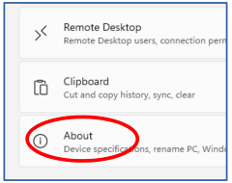
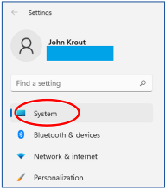
Open the Windows 11 Settings application. You can see the top portion of that window in Illustration 1
In the left-hand pane of that window, tap the System heading, which is circled in the illustration.
Windows 11 includes a lot of info about me and my computer on these screens.
I have inserted blue boxes atop the personal information that is not relevant.
Illustration 21
Illustration 11
In the right-hand System pane, scroll to the bottom. Find and click the About heading, shown and circled in illustration 2. That click opens another right-hand pane.
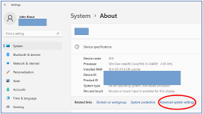
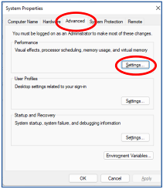
You can see the top of that next pane in illustration 3.
Click the Advanced System Settings link, which is circled in the illustration.
That click opens the System Properties dialog box,
as illustrated in illustration 4.
Illustration 31
Next, click the Advanced tab in that box, which is circled at the top of the illustration. Then, in that tab, in the Performance section at the top, click the Settings button circled in the illustration.
Illustration 41
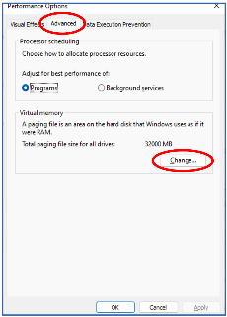
That click opens the Performance Options dialog box, as illustrated in illustration 5. In that dialog box, click the Advanced tab circled in the illustration.
When I captured that illustration, I had already adjusted my computer's space for virtual memory to be 32000 megabytes, or almost 32 gigabytes, roughly twice the RAM in my computer. You can see that updated value in the Virtual Memory section at the bottom of the Advanced tab in the illustration. Initially, the default value shown there was a bit less than 3000MB, far less than the RAM in my computer, which in my opinion, is an unreasonably small paging file size for editing bulky digital data.
In that Advanced tab Virtual Memory section, click the Change button at the bottom, circled in the illustration.
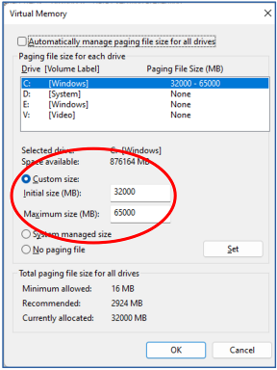
A Virtual Memory dialog box appears, which is shown in illustration 6. To adjust the default value for
drive C, in the list box identifying drives, click Drive C, then click the Custom Size button. The button is circled in the illustration and the data entry fields for initial and maximum Paging File sizes. The settings include an Initial Paging Size value, which I set to 32000 MB, and a Maximum Size value, which I set to 65000 MB. Neither size is a challenge for my new computer's 1 terabyte SSD drive C.
Illustration 51
I do not store my data in any of the Drive C user folders. Instead, I keep the data on a separate drive, a habit formed in the days when sometimes a hard drive C died. Of course, that is less likely today with a far more energy-efficient SSD drive C. Nonetheless, my habit continues, partly because it is far easier to move my data to a new computer when stored in an external hard drive. And my external drives in modern USB3 SATA docks provide acceptable performance.
Illustration 61

ABOUT THE AUTHOR: John Krout is a retired software engineer who helped create requirements, design, and improve computer systems for federal government agencies in the Washington DC region for over three decades. He has been writing about the creative uses of personal computers since the early 1980s. Now he also writes about smartphones, tablets, and digital cameras. He is a member of the APCUG Speakers Bureau.
____________________________________________________________________
Please do NOT print the author's email address in your newsletter. However, if you do publish this article, please send a PDF copy of the newsletter containing the article to jkrout.apcug.presenter@gmail.com.

